CIVILIZATIONS OF THE AMERICAS
DBQ

This task is based on the accompanying documents. Some of these documents have been edited for the purpose of this task. This task is designed to test your ability to work with historic documents. As you analyze the documents, take into account both the source of the document and the author’s point of view

Historical Context
Between 300 and 1500, three advanced civilizations developed in Central and South America. Ruins from the Mayan civilization remain even today in southern Mexico, Guatemala, and Honduras. The Aztecs, who conquered most of Mexico, built a highly-developed civilization in the 1400’s. At the same time, the Incas were building an empire in Peru.

Directions
The following question is based on the accompanying documents. As you analyze the documents, take into account both the source of the document and the author’s point of view. Be sure to:
- Carefully read the document-based question. Consider what you already know about the topic. How would you answer the question if you had no documents to examine?
- Now, read each document carefully, underlining key phrases and words that address the document-based question. You may also wish to make notes. Answer the questions which follow each document.
- Based on your own knowledge and on the information found in the documents, formulate a thesis that directly answers the question.
- Organize supportive and relevant information into a brief outline.
- Write a well-organized essay proving your thesis. The essay should be logically presented and should include information both form the documents and from your own knowledge outside the documents.

Document 1: This pyramid in Tikal was the tallest structure in the Americas until the twentieth century.
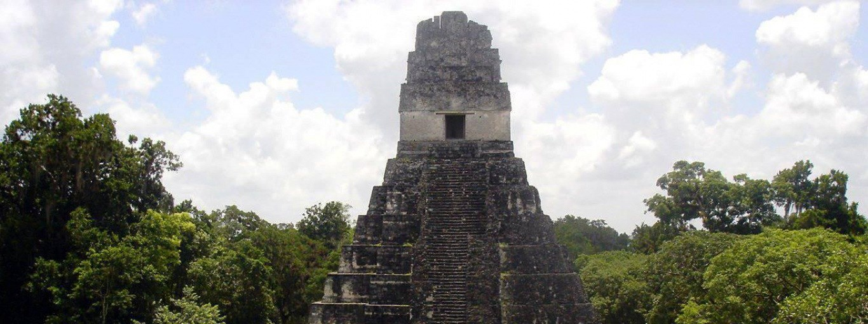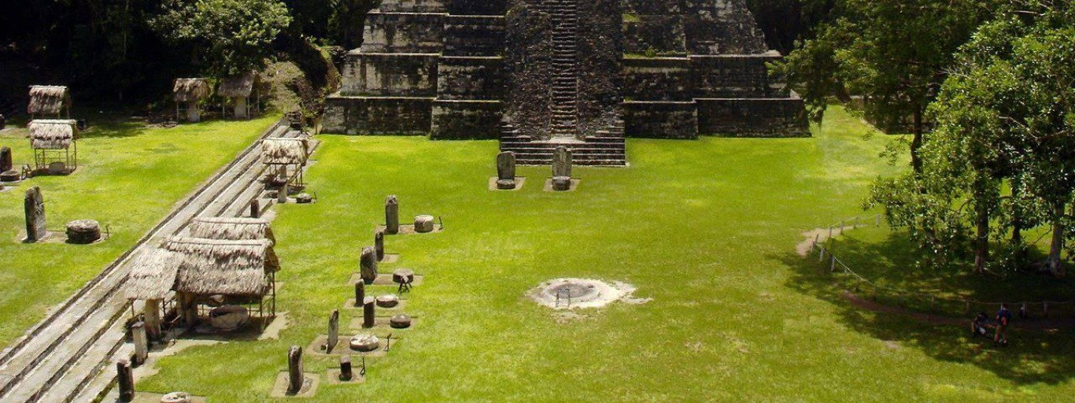

Q: Describe the significance of Mayan architecture evidenced in this temple at Tikal?

Document 2: This is a glyph from the Mayan calendar
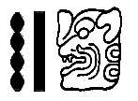
Q: What is the significance of this glyph (symbol)?

Document 3: When he arrived in 1519, the Spanish conqueror Hernán Cortés described the magnificent Aztec of Tenochtitlán with these words.

“The city has many squares where markets are held and trading is carried on. There is one square…where there are daily more than 60,000 souls, buying and selling, and where are found all the kinds of merchandise produced in these countries, including food products, jewels of gold and silver, lead, brass, copper, zinc, bones,
shells, and feathers.”

Q: Why was Cortés impressed when he arrived in Tenochtitlán in 1519?

Document 4: This description of farming in the Incan empire in 1539 was provided by Garciasco de la Vega, a son of an Incan princess and a Spanish explorer.

As soon as the Incan ruler had conquered any kingdom and set up his government, he ordered that the farmland used to grow corn be extended. For this purpose, he ordered irrigation channels to be constructed. The
engineers showed great cleverness and skill in supplying water for the crops, since only scattered sections of the land could grow corn. For this reason, they endeavored to increase its fertility as much as possible.
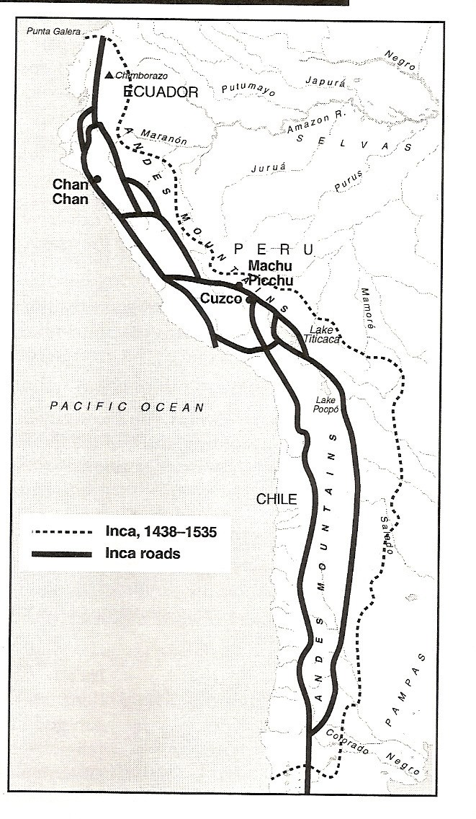
Q: What engineering technique was described by this sixteenth-century author?
Q: Why was this a significant achievement?

Document 5: This map shows the incan Empire in 1565

Q: How did the Incan government unite its empire in the Andes Mountains?
Q: What is the significance of this accomplishment?

Document 6: These photos of the ruins of Machu Picchu provide evidence of the superior building design and farming techniques of the Inca in Peru..

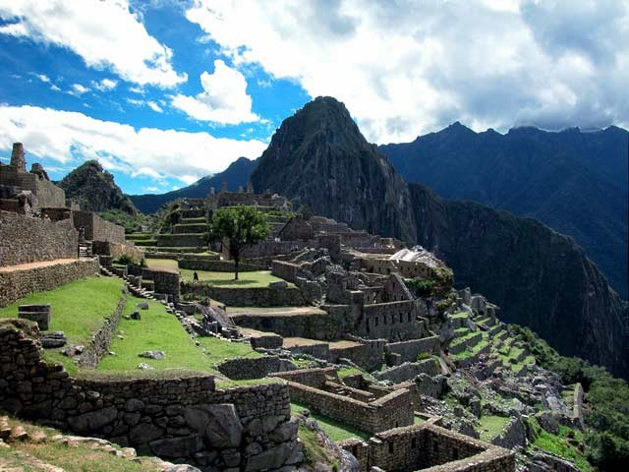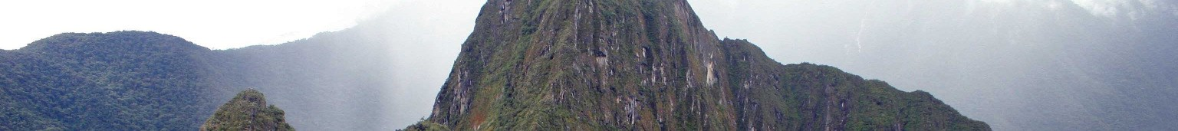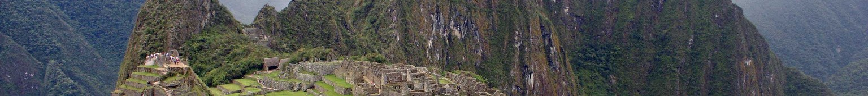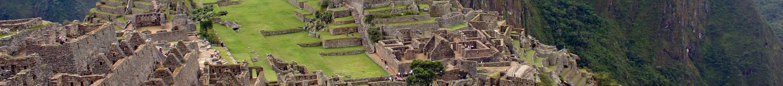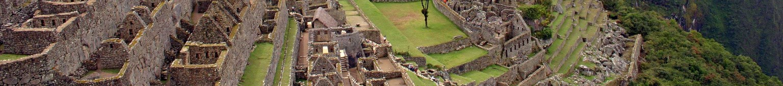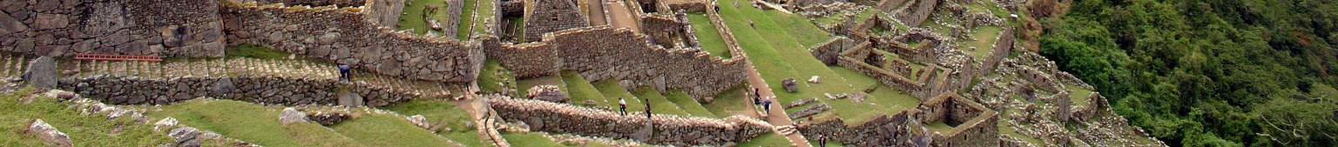

Q: What specific farming and building techniques were used by the Incas?

ESSAY –

HOW ADVANCED WERE THE MAYAN, AZTEC, AND INCAN CIVILIZATIONS? WHAT WERE THEIR MAJOR ACCOMPLISHMENTS?

Task: Using information from the documents and your knowledge of world history write an essay in which you:
- Discuss and evaluate the achievements of the people of Ancient American civilizations.
- Use at least 4 documents in your response.

Be sure to include specific historical details. Your essay must also include additional information from your knowledge of world history.

©1999 J. Weston Walch

